1. INTRODUCTION
The rapid growth of global e-commerce has increased the complexity of supply chain and shipment management. Timely delivery is important for maintaining customer satisfaction and operational efficiency. However, shipment delays can occur due to various factors related to shipping methods, customer information, product characteristics, geographical conditions, and order timing. Predicting the possibility of delay in advance can help improve supply chain decision-making.
Traditional approaches often depend on manual monitoring and historical analysis to identify delivery problems. When large volumes of supply chain data are involved, these approaches can become time-consuming. Machine Learning provides an effective approach by learning patterns from historical shipment records and using them to predict future delivery risks.
SupplyGuard: AI-Powered Shipment Delay Prediction System is a Machine Learning-based project developed to predict shipment late-delivery risk using historical supply chain data. The project uses the DataCo Smart Supply Chain Dataset, containing 180,519 records and 53 attributes related to customers, products, orders, shipments, markets, and geographical information.
The target variable used is Late_delivery_risk, which indicates whether a shipment is associated with late-delivery risk. Relevant shipment, customer, product, market, geographical, and temporal features are selected for model development. Calendar-based features are also derived from order-date information, along with an interaction feature between shipping mode and order hour.
Two Machine Learning algorithms, Random Forest and Support Vector Machine (SVM), are evaluated for late-delivery-risk classification. Their performance is compared using Accuracy, Precision, Recall, F1-Score, and ROC-AUC. The final system uses a Random Forest model with 500 decision trees.
A web-based interface is provided to demonstrate the trained model. Users can enter the required shipment information through the webpage, and the saved Machine Learning pipeline generates a late-delivery probability and corresponding risk prediction.
2. SUPPORTING LITERATURE
2.1 Literature Review
Paper 1 - A Novel Machine Learning Model for Predicting Late Supplier Deliveries of Low-Volume-High-Variety Products with Application in a German Machinery Industry
The research titled “A Novel Machine Learning Model for Predicting Late Supplier Deliveries of Low-Volume-High-Variety Products with Application in a German Machinery Industry” focuses on predicting supplier delivery delays in a low-volume-high-variety manufacturing environment. The study highlights the importance of using Machine Learning techniques to analyze purchasing data and identify patterns associated with late supplier deliveries. Early prediction of potential delivery delays can help manufacturing organizations improve procurement and production planning.
The proposed approach uses real purchasing data collected from a German machinery manufacturer. The study builds a detailed understanding of the manufacturer's procurement process and identifies relevant features that can be used for predicting supplier delivery performance. The data is analyzed and prepared before applying different Machine Learning algorithms to determine their suitability for predicting the severity of late deliveries.
The researchers evaluate several supervised Machine Learning algorithms and develop a regression-based prediction model for estimating the severity of supplier delivery delays. The study demonstrates that prediction is possible during earlier phases of the purchasing process. It also shows that high-dimensional input features do not necessarily require dimensionality reduction, allowing a larger set of relevant information to be considered during prediction.
The study shows that Machine Learning-based prediction can help organizations identify potential supplier delivery problems at an early stage and support better procurement and production planning. However, the research mainly focuses on predicting the severity of supplier delivery delays and does not provide an integrated supplier recommendation and manager approval system. The proposed SupplyGuard system extends this concept by combining shipment delay-risk prediction with a rule-based supplier recommendation module based on supplier reliability, pending workload, and active status, providing a practical decision-support solution for logistics management.
TITLE | A Novel Machine Learning Model for Predicting Late Supplier Deliveries of Low-Volume-High-Variety Products with Application in a German Machinery Industry
AREA OF WORK
  Development of a Machine Learning-based regression framework for predicting the severity of late supplier deliveries in a low-volume-high-variety manufacturing environment to support procurement and production planning.
DATASET
  Real purchasing and supplier delivery data collected from a German machinery manufacturer, representing a low-volume-high-variety production environment and containing information related to the purchasing process and supplier deliveries.
METHODOLOGY / STRATEGY | Data analysis, procurement-process understanding, relevant feature identification, preparation of purchasing data, supervised Machine Learning model development, comparison of different Machine Learning algorithms, and evaluation of their ability to predict the severity of supplier delivery delays.
ALGORITHM | Regression-based Machine Learning models  • Multiple Machine Learning algorithms were compared to identify a suitable prediction approach.
RESULT / PRECISION | The study demonstrates that Machine Learning can predict the severity of supplier delivery delays during earlier phases of the purchasing process. It also shows that high-dimensional input features do not necessarily require dimensionality reduction for the proposed prediction approach.
ADVANTAGES | The proposed approach enables organizations to predict potential supplier delivery delays at an early stage, supporting better procurement and production planning. It makes use of high-dimensional purchasing information without requiring mandatory dimensionality reduction and can help organizations take preventive actions to reduce the impact of supplier delays.
FUTURE PROPOSAL | Future improvements can include the integration of additional information such as component identifiers and other relevant procurement-related features to improve prediction quality and make the model more effective for practical supplier-delivery prediction.
Table 2.1 Summary of Paper 1

Paper 2 - Integrating Machine Learning and Deep Learning for Enhanced Supplier Risk Prediction
The research titled "Integrating Machine Learning and Deep Learning for Enhanced Supplier Risk Prediction in Supply Chain Management" focuses on improving supplier selection and risk assessment using Artificial Intelligence techniques. Supplier-related issues such as delayed deliveries, inconsistent product quality, and capacity constraints can significantly affect the overall performance of a supply chain. The study highlights the importance of identifying high-risk suppliers at an early stage to ensure uninterrupted logistics operations and maintain customer satisfaction. By integrating Machine Learning and Deep Learning models, the researchers aim to develop a robust framework for predicting supplier risks and supporting strategic procurement decisions.
The proposed approach uses historical supplier data collected from an automotive manufacturer's ERP system. The dataset contains information related to suppliers, quality issues, failure descriptions, issue severity, plant location, replacement time, recurrent issues, total cost, response time, and other supplier-related factors. The data is processed and relevant features are selected before applying the Machine Learning and Deep Learning models.
The researchers evaluate multiple models for both classification and regression tasks. The classification models include Random Forest, SVM, KNN, and ANN, while regression models include Random Forest Regressor, SVR, Linear Regression, and ANN. The models are compared using appropriate evaluation metrics to determine their effectiveness in predicting supplier failures, number of issues, and disruption costs.
The study shows that Machine Learning can effectively identify supplier-related risks and support proactive supply chain management. However, the research mainly focuses on supplier failure and risk prediction and does not provide an integrated shipment-delay prediction and supplier recommendation system. The proposed SupplyGuard system extends this concept by combining shipment delay-risk prediction with a rule-based supplier recommendation module based on supplier reliability, pending workload, and active status, providing a practical decision-support solution for logistics management.
TITLE | Integrating Machine Learning and Deep Learning for Enhanced Supplier Risk Prediction
AREA OF WORK | Application of Machine Learning and Deep Learning techniques for predicting supplier-related risks, failures, issues, and disruption costs in supply chain management.
DATASET | The study utilizes historical supplier performance data containing supplier reliability, delivery history, production capacity, order completion rates, quality metrics, and customer feedback.
METHODOLOGY / STRATEGY | The dataset is preprocessed through data cleaning, normalization, feature engineering, and missing value handling. Machine Learning and Deep Learning models are trained and evaluated using classification performance metrics to identify supplier risks accurately.
ALGORITHM | Random Forest, SVM, KNN, ANN, Random Forest Regressor, SVR, Linear Regression
RESULT / PRECISION
  The integrated Machine Learning and Deep Learning framework achieves high prediction accuracy by effectively classifying suppliers based on their reliability and operational risk, thereby improving procurement decisions.
ADVANTAGES
  The proposed approach enables organizations to identify high-risk suppliers before procurement decisions are made. It improves supplier evaluation, reduces procurement risks, enhances supply chain resilience, and supports better decision-making by utilizing historical supplier performance data.
FUTURE PROPOSAL | Future enhancements include integrating real-time supplier performance monitoring, IoT-based inventory tracking, external market indicators, and explainable Artificial Intelligence techniques to improve prediction transparency and decision-making accuracy.
Table 2.2 Summary of Paper 2
Paper 3 - A Deep Learning Approach to Predict Supply Chain Delivery Delays Based on Macroeconomic Indicators
The research titled "A Deep Learning Approach to Predict Supply Chain Delivery Delays Based on Macroeconomic Indicators" investigates the use of Deep Learning techniques to improve the prediction of shipment delivery delays in complex supply chain environments. The study emphasizes that conventional prediction models primarily rely on historical shipment records and often overlook external factors that influence delivery performance. To address this limitation, the researchers propose a predictive framework that combines logistics data with macroeconomic indicators such as fuel prices, inflation rates, transportation costs, and economic conditions to achieve more accurate delay predictions.
The proposed system collects historical shipment information along with relevant economic indicators that may affect transportation and logistics operations. Before model training, the collected data undergoes preprocessing steps including data cleaning, feature selection, normalization, and transformation of categorical variables into numerical representations. The Deep Learning model is then trained to identify hidden relationships between shipment characteristics and external economic factors that contribute to delivery delays. Performance is evaluated using standard metrics such as Accuracy, Precision, Recall, F1-Score, and Mean Absolute Error (MAE).
Experimental results indicate that Deep Learning models outperform several traditional Machine Learning algorithms by effectively capturing complex nonlinear relationships within the dataset. The study demonstrates that incorporating macroeconomic indicators significantly improves prediction accuracy and enables organizations to anticipate delivery disruptions more effectively. However, the proposed framework mainly focuses on shipment delay prediction and does not include supplier evaluation or recommendation mechanisms. The proposed SupplyGuard system builds upon this concept by integrating shipment delay prediction with supplier recommendation based on supplier reliability and workload, thereby providing a more comprehensive logistics decision-support solution.
TITLE | A Deep Learning Approach to Predict Supply Chain Delivery Delays Based on Macroeconomic Indicators
AREA OF WORK
  The research focuses on predicting supply chain delivery delays using Deep Learning techniques by combining historical delivery information with macroeconomic indicators that may influence supply chain and transportation performance.
DATASET
  The study utilizes historical shipment records along with macroeconomic data such as fuel prices, transportation costs, inflation rates, economic conditions, and delivery schedules.
METHODOLOGY / STRATEGY | The collected data is preprocessed through cleaning, normalization, feature engineering, and encoding of categorical variables. A Deep Learning model is trained to identify hidden relationships between shipment attributes and external economic factors affecting delivery performance.
ALGORITHM | Deep Neural Network (DNN), Long Short-Term Memory (LSTM), and Artificial Neural Network (ANN) models are implemented to predict shipment delivery delays.
RESULT / PRECISION
  The Deep Learning models achieve higher prediction accuracy by incorporating macroeconomic indicators, enabling organizations to identify potential shipment delays more effectively than traditional prediction methods.
ADVANTAGES | The proposed approach improves the accuracy of shipment delay prediction by considering both historical logistics data and external economic factors. It enables proactive logistics planning, reduces transportation risks, enhances resource utilization, and supports informed decision-making for supply chain managers.
FUTURE PROPOSAL | Future work recommends integrating real-time weather information, GPS tracking, traffic conditions, IoT sensor data, and supplier performance metrics to develop a more intelligent and adaptive supply chain prediction system capable of responding to dynamic logistics environments.
Table 2.3 Summary of Paper 3

2.2 Literature Review Summary
TITLE
  SUMMARY
Fabian Steinberg et al., “A Novel Machine Learning Model for Predicting Late Supplier Deliveries of Low-Volume-High-Variety Products with Application in a German Machinery Industry,” Supply Chain Analytics, 2023 | This study focuses on predicting the severity of late supplier deliveries in a low-volume-high-variety manufacturing environment. The authors develop a Machine Learning-based regression model using purchasing data from a German machinery manufacturer and compare different Machine Learning algorithms to identify the most suitable prediction approach. The study demonstrates that supplier delivery delays can be predicted during earlier phases of the purchasing process and that high-dimensional input features do not necessarily require dimensionality reduction. The research shows the potential of predictive analytics for improving procurement and production planning. However, the study focuses mainly on predicting supplier delivery delay severity and does not include supplier recommendation, workload balancing, or manager approval within an integrated decision-support system.
N. Rezki and M. Mansouri, “Integrating Machine Learning and Deep Learning for Enhanced Supplier Risk Prediction.” | This research focuses on predicting supplier risks using Artificial Intelligence techniques. Historical supplier performance data is analyzed using Machine Learning and Deep Learning algorithms to identify reliable suppliers and minimize procurement risks. The study demonstrates that AI-based supplier evaluation improves procurement decisions and strengthens supply chain resilience. However, the framework does not include shipment delay prediction or integrated logistics management.
Gabellini et al., “A Deep Learning Approach to Predict Supply Chain Delivery Delays Based on Macroeconomic Indicators. | This paper proposes a Deep Learning model that combines historical shipment records with macroeconomic indicators such as fuel prices and transportation costs to predict delivery delays. The results show that Deep Learning improves prediction accuracy by capturing complex relationships between logistics and external factors. Nevertheless, the study does not provide supplier recommendation or workload optimization, leaving scope for a more comprehensive logistics decision-support system.
Table 2.4 Overall Summary of all paper
2.3 Findings and Proposals
The literature review reveals that Artificial Intelligence and Machine Learning have become increasingly important in improving supply chain management. The reviewed studies demonstrate that predictive models can analyze historical logistics data to identify shipment delays and assess supplier-related risks. These approaches help organizations improve operational efficiency, reduce supply chain risks, and support proactive decision-making.
The first research paper highlights the application of several Machine Learning algorithms, including Random Forest, Gradient Boosting, KNN, Decision Tree, Logistic Regression, Linear Regression, and SVM, for proactive supply chain risk management and shipment-delay prediction. The second paper focuses on supplier risk prediction using Machine Learning and Deep Learning techniques, enabling organizations to identify supplier-related risks and support better procurement decisions. The third paper further explores shipment-delay prediction using an LSTM-based Deep Learning approach combined with macroeconomic indicators, demonstrating the importance of considering external factors in supply chain prediction.
Although these studies contribute significantly to intelligent supply chain management, several limitations are observed. Most existing systems concentrate on a specific problem, such as shipment delay prediction or supplier risk assessment. Few approaches integrate shipment-delay prediction with supplier recommendation in a unified decision-support system. In addition, existing approaches do not directly provide a practical mechanism for recommending an active supplier based on reliability and current workload while allowing a manager to make the final approval decision.
Based on these findings, the proposed SupplyGuard – AI-Powered Shipment Delay Prediction and Supplier Recommendation System is designed to address these limitations. The system evaluates Random Forest and Support Vector Machine (SVM) for shipment delay-risk prediction using selected historical logistics features. In addition to delay prediction, the system provides a rule-based supplier recommendation by considering supplier reliability, pending orders, and active status. This integrated approach helps logistics managers identify potential delivery risks, select a suitable available supplier, and make informed approval decisions.
The proposed system is implemented using React.js for the frontend, FastAPI for backend services, MongoDB Atlas for cloud-based database management, and Machine Learning models developed in Python using scikit-learn and Joblib. The integration of predictive analytics, rule-based supplier recommendation, shipment storage, and manager approval provides a practical decision-support solution for proactive supply chain management.
2.4 Problem Statement
Supply chain management plays a crucial role in ensuring the timely delivery of products and maintaining customer satisfaction. However, shipment delays caused by supplier-related issues, transportation conditions, operational problems, and improper logistics planning continue to be major challenges for organizations. These delays can increase operational costs, disrupt business activities, and negatively affect customer satisfaction.
Most existing logistics management systems are designed to monitor shipment status after dispatch rather than predict potential delays in advance. As a result, logistics managers may become aware of delivery problems only after they have occurred, leaving limited opportunities to take preventive actions. In addition, supplier selection is often based on manual evaluation or historical experience, which may not sufficiently consider the current reliability and workload of available suppliers.
The absence of an integrated decision-support system that combines shipment delay prediction with supplier recommendation makes it difficult for organizations to proactively manage delivery risks. Therefore, there is a need for a system that can predict shipment delay risk using Machine Learning techniques and recommend a suitable active supplier based on supplier reliability and pending workload. Such a system can help managers take proactive measures, improve logistics planning, support supplier selection, and enhance the overall efficiency of supply chain operations.
2.5 Research Gap
The literature review indicates that considerable research has been conducted on shipment delay prediction and supplier risk assessment using Machine Learning and Deep Learning techniques. These studies have demonstrated the effectiveness of predictive models in improving logistics planning, reducing operational risks, and enhancing supply chain performance. However, several limitations still exist in the current approaches.
Most existing research focuses mainly on predicting shipment delays without providing recommendations for selecting the most suitable supplier. Similarly, studies related to supplier risk assessment mainly focus on evaluating supplier-related risks but do not integrate shipment delay prediction into the decision-making process. As a result, logistics managers may need to use separate systems or manual analysis to make operational decisions.
Another significant gap is the limited consideration of supplier workload and reliability during supplier selection. Existing approaches generally focus on prediction or risk assessment and lack an integrated platform that combines predictive analytics with supplier recommendation. Furthermore, many approaches do not provide practical decision-support features that can help organizations proactively respond to potential shipment delays.
To address these research gaps, the proposed SupplyGuard – AI-Powered Shipment Delay Prediction and Supplier Recommendation System integrates shipment delay prediction with supplier recommendation in a single platform. By utilizing Random Forest and Support Vector Machine (SVM) algorithms along with supplier reliability and workload analysis, the proposed system provides a comprehensive decision-support solution that enables organizations to reduce delivery delays, improve supplier selection, and enhance the overall efficiency of supply chain management.
2.5 Motivation
The rapid growth of global trade and e-commerce has increased the demand for efficient and reliable supply chain management systems. Organizations are required to ensure timely delivery of products while minimizing operational costs and maintaining high levels of customer satisfaction. However, shipment delays caused by supplier inefficiency, transportation disruptions, and ineffective logistics planning continue to pose significant challenges to businesses.
Existing logistics systems primarily focus on tracking shipments after dispatch rather than predicting potential delays before they occur. Moreover, supplier selection is often based on manual analysis or historical experience, which may not accurately reflect the current reliability and workload of suppliers. These limitations reduce the ability of organizations to make proactive decisions and respond effectively to potential supply chain disruptions.
The motivation behind developing the SupplyGuard – AI-Powered Shipment Delay Prediction and Supplier Recommendation System is to provide an intelligent decision-support platform that enables organizations to anticipate shipment delays and recommend the most suitable suppliers before delivery issues arise. By leveraging Machine Learning algorithms such as Random Forest and Support Vector Machine (SVM), the system analyzes historical shipment data to predict delay risks with high accuracy.
In addition to delay prediction, the proposed system evaluates supplier reliability and workload to recommend the most appropriate supplier for each shipment. This integrated approach helps organizations improve logistics planning, optimize supplier utilization, reduce operational costs, minimize delivery failures, and enhance customer satisfaction. The project demonstrates how Artificial Intelligence can be effectively applied to modern supply chain management to achieve smarter, faster, and more reliable logistics operations.
3. SYSTEM ANALYSIS
System analysis is the process of examining the existing system, identifying its limitations, and designing an efficient solution to meet the required objectives. It helps in understanding the system requirements, data flow, and overall functionality before implementation.
The proposed SupplyGuard – AI-Powered Shipment Delay Prediction and Supplier Recommendation System analyzes historical shipment data to predict delivery delays and recommend suitable suppliers based on reliability and workload. The system utilizes Machine Learning techniques to improve logistics planning, reduce operational risks, and support better decision-making. This chapter discusses the dataset, data preprocessing, visualization, system architecture, algorithms, project pipeline, and feasibility analysis of the proposed system.
3.1 Analysis of Dataset
3.1.1 About the Dataset
a) Dataset Overview
The SupplyGuard – AI-Powered Shipment Delay Prediction and Supplier Recommendation System utilizes the DataCo Smart Supply Chain Dataset to develop Machine Learning models for predicting shipment delays and supporting supplier recommendations. The dataset contains historical supply chain records collected from logistics operations and is widely used for research in supply chain analytics and predictive modeling. It includes information related to customer orders, products, suppliers, shipments, transportation, delivery status, and sales transactions.
The dataset consists of 180,519 records and 53 attributes, containing both numerical and categorical features. The numerical attributes include sales amount, shipping cost, order item quantity, scheduled delivery days, actual delivery days, benefit per order, and product price. The categorical attributes include shipping mode, order status, delivery status, customer segment, product category, supplier information, order region, and market. These attributes are used to identify patterns that influence shipment delays and logistics performance.
The target variable used in the proposed system is Late_delivery_risk, which is a binary classification attribute indicating whether a shipment is delayed (1) or delivered on time (0). The dataset is well suited for supervised Machine Learning classification and provides sufficient information to analyze the factors affecting shipment delays and supplier performance.
Name | DataCo Smart Supply Chain Dataset
Source | Kaggle
Size | 180,519 Records
Attributes | 53
Predictor Variables | 31
Target Variable | Late_delivery_risk
Target Classes | 0 (On-Time), 1 (Delayed)
Class 0  Class 1  Data Types | 81,542  98,977  Numerical and Categorical

The following are the feature categories:
1. Shipment Features
- Shipping Mode
- Days for shipment (scheduled)
- Order Item Quantity
- Order Item Product Price
- Order Item Discount Rate
- Sales
2. Customer Features
- Customer Segment
- Customer City
- Customer State
- Customer Country
3. Product Features
- Category Name
- Department Name
- Type
4. Market and Logistics Features
- Market
- Order Region
- Order Country
- Order State
5. Temporal Features
- Order Month
- Order Day
- Order Day of Week
- Order Hour
- Order Week of Year
- Order Day of Month
- Is Weekend
- Is Month Start
- Is Month End
- Is Quarter Start
- Is Quarter End
- Is Business Hour
- Is Night
- Interaction_ShippingMode_OrderHour
Target Variable
- Late_delivery_risk
3.1.2 Explore the Dataset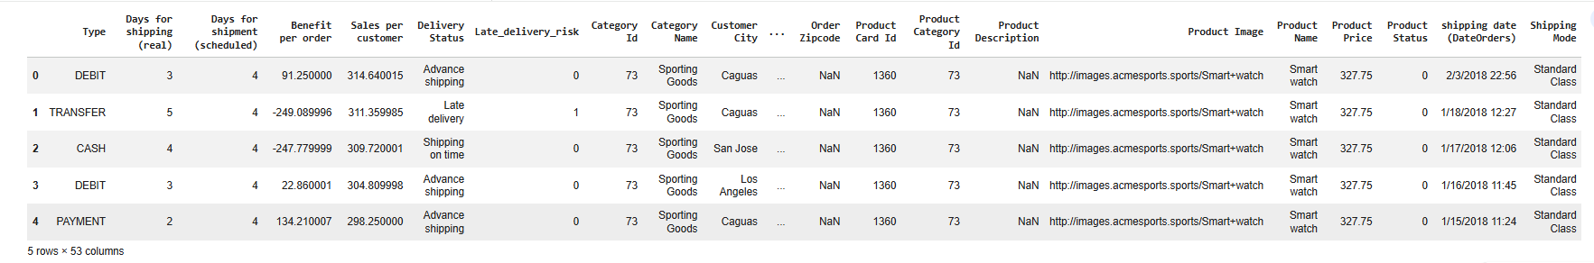 Fig 3.1 Preview of the DataCo Smart Supply Chain Dataset

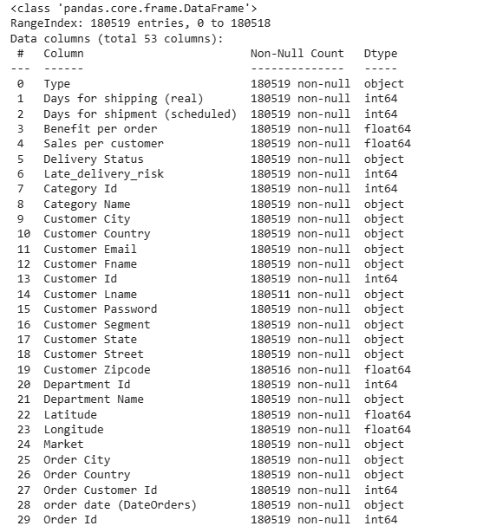
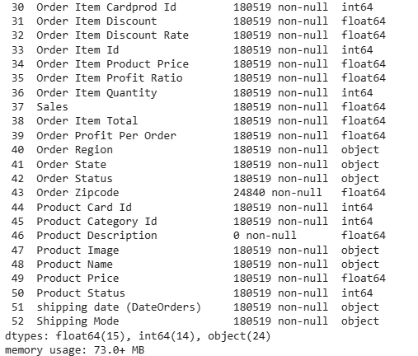
Fig 3.2 Information of the Dataset
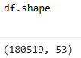
Fig 3.3 Shape of the Dataset

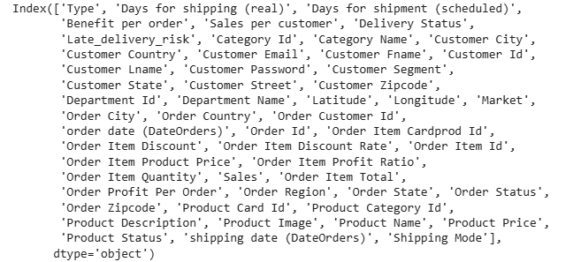
Fig 3.4 Dataset Attributes (Column Names)

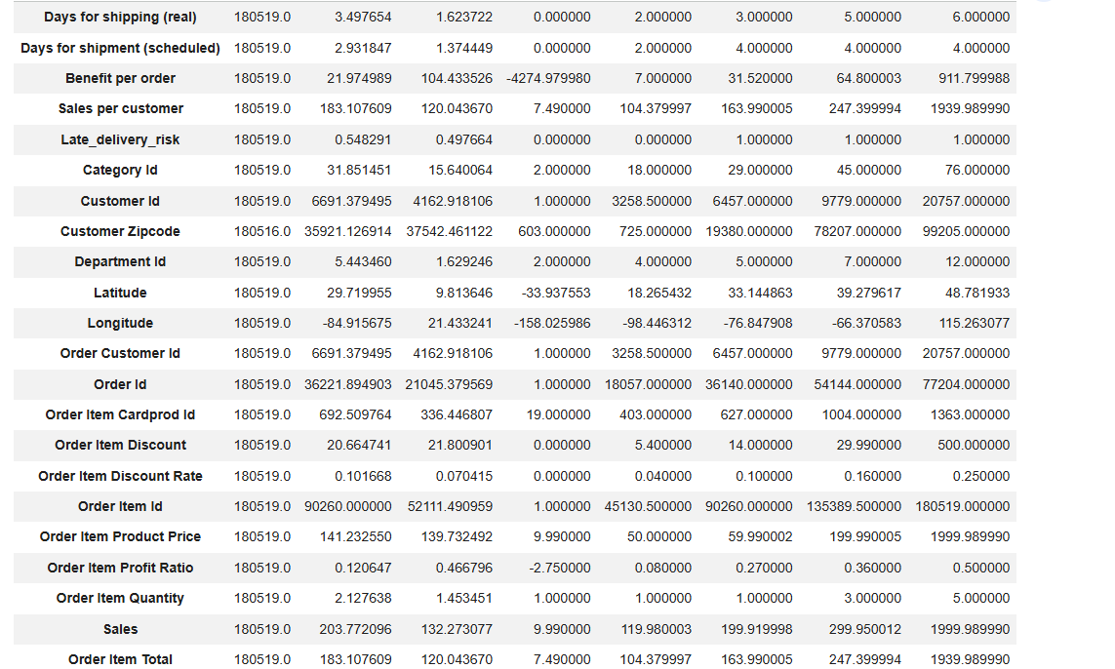

Fig 3.5 Statistical Summary

3.2 Data Preprocessing
Missing values were present in some of the original dataset attributes. These attributes were excluded during feature selection and were therefore not used as inputs to the final prediction model. The 31 selected model features contained no missing values, so imputation was not required.

3.2.1 Data Cleaning
a) Checking for Missing Values
Data preprocessing is a crucial Machine Learning step that prepares the dataset for model training. In SupplyGuard – AI-Powered Shipment Delay Prediction System, the DataCo Smart Supply Chain Dataset is processed by checking missing values, removing duplicates where necessary, selecting relevant features, encoding categorical variables, and splitting the data into training and testing sets. The final 31 selected features contain no missing values, so missing-value imputation is not required. These steps prepare the data for training and evaluation of the Random Forest and Support Vector Machine (SVM) models for shipment late-delivery-risk prediction. 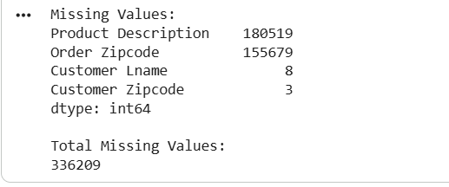
Fig 3.6 Missing values

b) Check for Duplicates
Duplicate records were checked and removed from the dataset to avoid repeated information and prevent bias during model training. The analysis showed that there were 0 duplicate records present in the dataset. Therefore, no records were removed during this step, and the dataset retained its original size of 180,519 records with 53 features after duplicate checking.

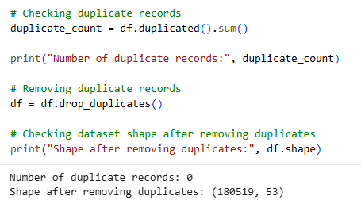
Fig 3.7 checking duplicates
c) Outlier Handling
Outlier analysis was performed on the numerical features of the SupplyGuard dataset using the Interquartile Range (IQR) method. Some extreme values were identified in numerical attributes such as order quantity, product price, discount rate, and sales. These values represent valid variations in supply chain transactions rather than data entry errors. Therefore, the identified outliers were retained without removal or transformation

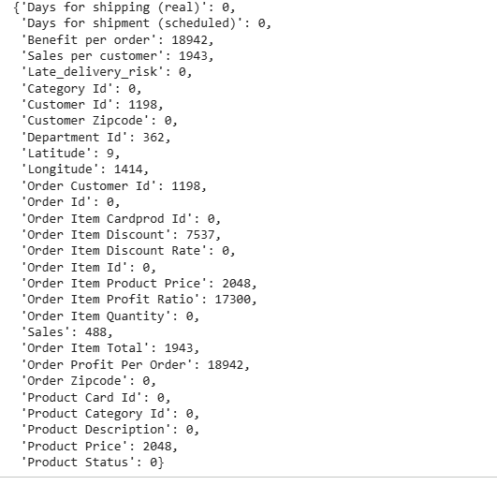
Fig 3.8 Outliers Indentified
3.2.2 Analysis of Feature Variables
a) Feature Variables
The feature variables were analyzed to understand their characteristics, data types, distributions, missing values, and their relevance for Machine Learning model development. This analysis helps identify the important attributes, detect inconsistencies, and ensure that the dataset is suitable for further preprocessing and model training. The features were categorized into numerical and categorical variables based on their data types.
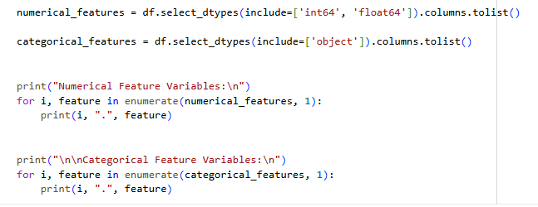
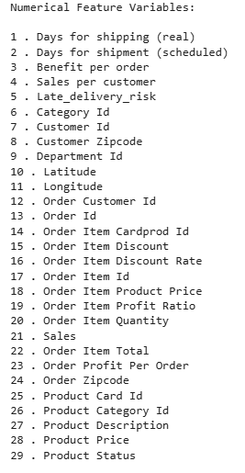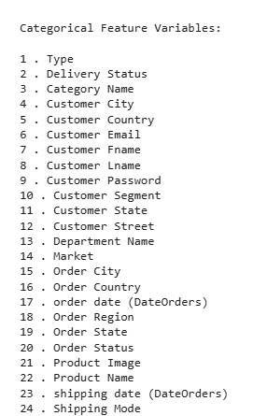
Fig 3.9 Feature Variables
b) Summary of feature variables
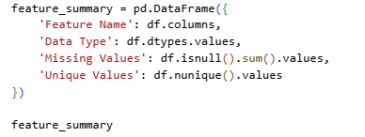
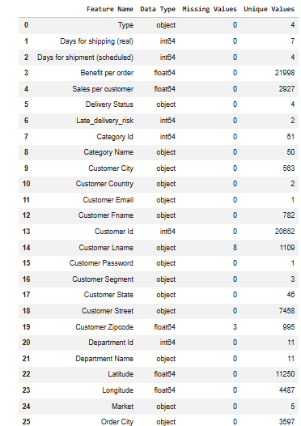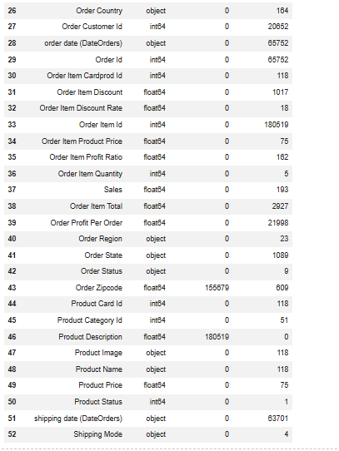
Fig 3.10 Summary of Feature Variables
3.2.3 Analysis of Class Variables
The class variable represents the output that the Machine Learning model aims to predict. In SupplyGuard, the target variable is Late_delivery_risk, where class 0 represents no late-delivery risk and class 1 represents late-delivery risk. The class distribution is analyzed to understand the representation of each class and its suitability for binary classification.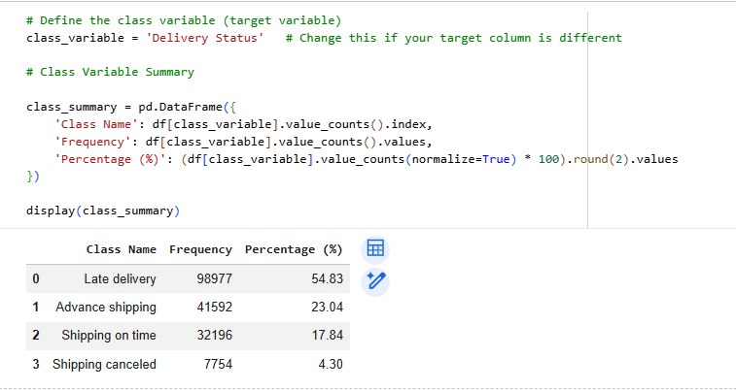
Figure 3.11 Summary of Class Variable
3.3 Data Visualization
"Data visualization is performed to represent the patterns, relationships, and distribution of data using graphical techniques. It helps in understanding the dataset more effectively by identifying trends, outliers, class distribution, and important relationships between variables. Various visualization methods such as count plots, histograms, box plots, and correlation heatmaps are used to analyze the SupplyGuard dataset before model development."
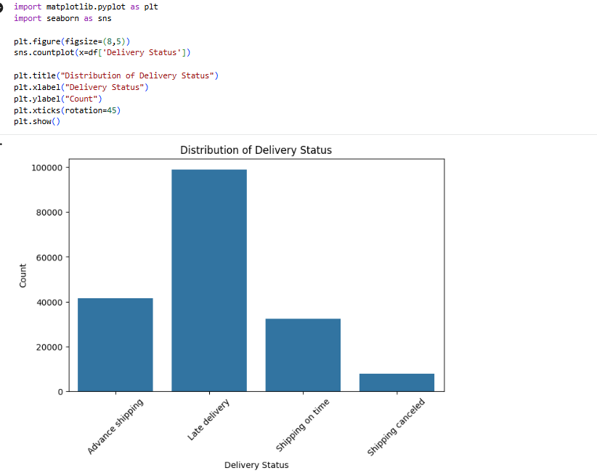
Figure 3.12 Data Visualization

3.4 Analysis of Architecture and Algorithms
The SupplyGuard system uses Machine Learning and supply chain data analysis to predict shipment late-delivery risk. The system follows a structured process in which shipment data is analyzed, relevant features are selected and engineered, and the data is preprocessed for model training. The processed data is then provided to classification algorithms to predict late-delivery risk.
Two supervised Machine Learning algorithms, Random Forest and Support Vector Machine (SVM), are evaluated for shipment late-delivery-risk prediction. Random Forest combines multiple decision trees to produce classification results, while SVM identifies a decision boundary between different classes using an RBF kernel. Both models are evaluated using Accuracy, Precision, Recall, F1-Score, and ROC-AUC. Based on the experimental results, Random Forest is used as the final prediction model.
3.4.1 Detailed Study Report of the Proposed Algorithm(s)
The SupplyGuard system uses supervised Machine Learning algorithms to predict shipment late-delivery risk. The selected dataset features are preprocessed and categorical variables are converted using One-Hot Encoding before model training. Two classification algorithms, Random Forest and Support Vector Machine (SVM), are evaluated using historical shipment data.
The system consists of three major components: Data Preprocessing, Feature Selection and Engineering, and Machine Learning Classification. Data preprocessing prepares the selected features for modelling, while feature selection and engineering identify the relevant variables and derive temporal and interaction features. The processed features are then used to train and evaluate the Random Forest and SVM models.
Random Forest is used as the final prediction model after comparing its performance with SVM using the selected evaluation metrics.
3.4.1.1 Random Forest
Random Forest is a supervised Machine Learning algorithm based on ensemble learning. It combines multiple decision trees to improve classification performance and reduce the risk of overfitting. Each tree is trained using randomly selected samples and features, and the outputs of the trees are combined to produce the final classification.
In SupplyGuard, Random Forest is used to classify shipments into late-delivery-risk and non-late-delivery-risk classes. It can model non-linear relationships between the selected shipment, customer, product, market, geographical, and temporal features. The algorithm also provides feature importance values for analyzing the contribution of the input features.
The final Random Forest model uses 500 decision trees, with min_samples_leaf = 2 and random_state = 42.
Steps involved in Random Forest:
- Selecting multiple random samples from the training dataset.
- Constructing individual decision trees using selected samples.
- Generating predictions from each decision tree.
- Combining all tree outputs to produce the final prediction.
The Random Forest algorithm can be mathematically represented as:
Prediction = Majority Vote (Tree₁, Tree₂, Tree₃, …, Treeₙ)
where each tree contributes independently to the final classification decision.
For classification, the Random Forest combines the predictions of individual decision trees to determine the final class. The final SupplyGuard model also produces a probability score, which is compared with a threshold of 0.41 to determine the final late-delivery-risk prediction.
The main advantages of Random Forest include:
- Combines multiple decision trees for classification.
- Reduced risk of overfitting compared to a single decision tree.
- Handles numerical and encoded categorical features effectively.
- Provides feature importance values.
- Can model non-linear relationships in the data.
3.4.1.2 Support Vector Machine (SVM) Algorithm
Support Vector Machine (SVM) is a supervised Machine Learning algorithm commonly used for classification problems. It identifies a decision boundary that separates different classes while maximizing the margin between them. In SupplyGuard, SVM is used to classify shipments into late-delivery-risk and non-late-delivery-risk classes.
An RBF (Radial Basis Function) kernel is used because it allows the model to represent non-linear relationships in the transformed feature space. The SVM model uses C = 1.0, gamma = scale, and probability estimation enabled.
Due to the higher computational cost of SVM on the complete training data, the SVM experiment was trained using a stratified subset of 30,000 records from the training data. The model was then evaluated using the same test set used for Random Forest.The working process of SVM involves:
- Preprocessing and scaling the input features.
- Transforming the data into a suitable feature space.
- Identifying important data points called support vectors.
- Determining an optimal decision boundary between the classes.
- Using the learned boundary to classify new shipment records.
The main objective of SVM is to find an optimal decision boundary that separates the different classes while maximizing the margin between them. For the SupplyGuard system, the decision boundary is used to distinguish between shipments with late-delivery risk and shipments without late-delivery risk.
The important features of SVM include:
- Effective classification of shipment delay risk into two classes.
- Ability to model non-linear relationships using kernel functions.
- RBF kernel support for handling complex patterns in shipment data.

- Effective performance with high-dimensional feature spaces after encoding.
- Uses support vectors to determine the optimal classification boundary.
- Provides a suitable alternative for comparison with the Random Forest algorithm.
3.4.1.3 Comparison of Proposed Algorithms
Random Forest and Support Vector Machine (SVM) are both supervised machine learning algorithms that provide effective solutions for classification problems. However, they differ in their learning approach, decision-making process, computational requirements, and performance characteristics
Feature | Random Forest | SVM
Learning Method | Ensemble learning using multiple decision trees | Margin-based classification method
Model Construction | Multiple trees are built independently | An optimal decision boundary is determined from the training data
Decision Process | Combines predictions from multiple trees using majority voting | Classifies data based on the learned decision boundary
Training Speed | Suitable for large datasets and supports parallel processing | Can require more computational time as dataset size increases
Overfitting Control | Reduces overfitting by combining multiple decision trees | Controls model complexity using margin maximization and regularization
Feature Importance | Provides feature-importance information | Does not directly provide tree-based feature importance
Dataset Suitability | Works well with large and complex structured datasets | Suitable for classification with high-dimensional feature spaces
SupplyGuard Training | Trained using the full training dataset with 500 trees | Trained using a stratified subset of 30,000 training records

3.4.2 Activity Diagram to Represent the Flow of the Algorithm(s)
The activity diagram illustrates the workflow of the SupplyGuard system, from shipment data processing to final late-delivery-risk prediction. The process includes data preprocessing, feature selection, feature engineering, One-Hot Encoding, and train-test splitting before the data is provided to the Random Forest and SVM models for evaluation.
The performance of the models is evaluated using Accuracy, Precision, Recall, F1-Score, and ROC-AUC. Based on the experimental results, Random Forest is used as the final prediction model. The trained model is integrated with the web interface, where shipment information is entered and the system generates a late-delivery probability and corresponding risk prediction.
The diagram provides a clear representation of the interaction between data preprocessing, feature engineering, Machine Learning model evaluation, prediction generation, and result display.
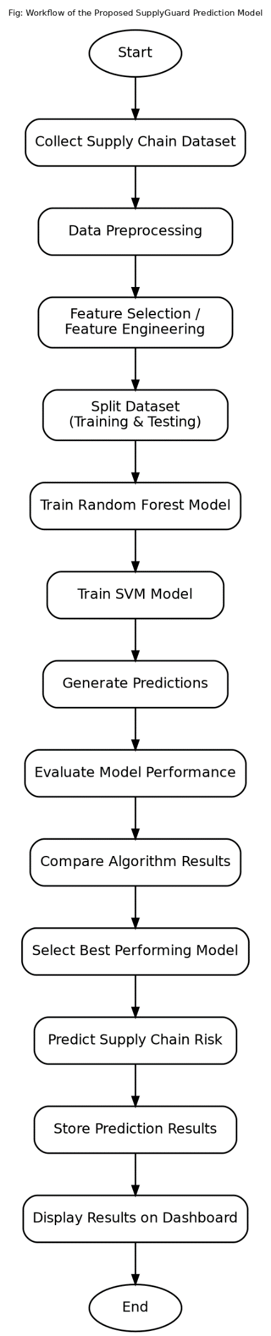
Figure 3.13 Activity Diagram of the Proposed SupplyGuard System

3.4.3 Step-by-Step Explanation about the Working of the Algorithm(s)
The proposed SupplyGuard system processes supply chain data through a sequence of data preprocessing, feature analysis, and Machine Learning techniques to predict potential shipment delays and improve supply chain decision-making. The complete working of the proposed algorithms, Random Forest and SVM, is described below.
Step 1: Collect Supply Chain Data
The process begins with the DataCo Smart Supply Chain Dataset, which contains historical supply chain records related to customers, products, orders, shipments, markets, and geographical information. The dataset is used as the source for developing the shipment late-delivery-risk prediction model.
Step 2: Load Dataset into the System
The dataset is loaded into the Python environment for analysis and model development. The structure, attributes, data types, missing values, duplicate records, and statistical characteristics of the dataset are examined before model preparation.
Step 3: Perform Data Preprocessing
The dataset is prepared for Machine Learning by checking missing values and duplicate records, excluding unsuitable attributes, selecting relevant features, and converting categorical variables into numerical form using One-Hot Encoding. The final selected features do not require missing-value imputation.
Step 4: Perform Feature Selection and Transformation
Relevant features are selected for shipment late-delivery-risk prediction. The final model uses 31 features consisting of categorical and numerical variables. Temporal features are derived from the order date (DateOrders) attribute, including order month, day, hour, day of week, weekend, and other calendar-related features. An interaction feature, Interaction_ShippingMode_OrderHour, is also created by combining Shipping Mode and Order Hou
Step 5: Split Dataset into Training and Testing Data
The processed dataset is divided into training and testing subsets using an 80:20 stratified split. The training set contains 144,415 records, while the test set contains 36,104 records. The training data is used for model development, and the test data is used to evaluate model performance on unseen records.
Step 6: Apply Random Forest and SVM Algorithms
The processed training data is used to evaluate the Random Forest and SVM classification algorithms. Random Forest combines the predictions of multiple decision trees to perform classification. The final Random Forest model uses 500 decision trees. SVM determines a decision boundary between the two classes and uses an RBF kernel to model non-linear relationships. Due to its higher computational cost, the SVM experiment is trained using a stratified subset of 30,000 records from the training data.
Step 7: Generate Risk Prediction
The trained models generate predictions for shipment late-delivery risk. The final Random Forest model also produces a probability score representing the predicted likelihood of late delivery. In SupplyGuard, the probability is compared with a threshold of 0.41. A probability of 0.41 or higher is classified as late-delivery risk, while a probability below 0.41 is classified as no late-delivery risk
Step 8: Evaluate and Compare Model Performance
Random Forest and SVM are evaluated using Accuracy, Precision, Recall, F1-Score, and ROC-AUC. Their results are compared based on the experimental configurations used in the project. Random Forest is selected as the final prediction model based on its measured performance.
Step 9: Store Prediction Results
The trained Random Forest model and its preprocessing components are saved as a Machine Learning pipeline. The saved pipeline allows new shipment information entered through the webpage to undergo the same preprocessing steps used during model development before generating a prediction.
Step 10: Display Results on the Dashboard
The webpage accepts the required shipment information as input and passes it to the saved SupplyGuard model pipeline. The system generates the late-delivery probability and displays the corresponding late-delivery-risk prediction to the user.
Step 11: Complete the Process
After displaying the prediction result, the process is completed. The webpage can then be used to enter another shipment record and generate a new late-delivery-risk prediction.
3.5 Project Pipeline
The project pipeline illustrates the sequential stages involved in the development and implementation of the proposed SupplyGuard system. It begins with dataset collection and proceeds through data analysis, feature selection and engineering, data preprocessing, model training, model evaluation, prediction, and result display. The pipeline provides a systematic workflow for processing shipmedata and predicting late-delivery risk using Machine Learning models.
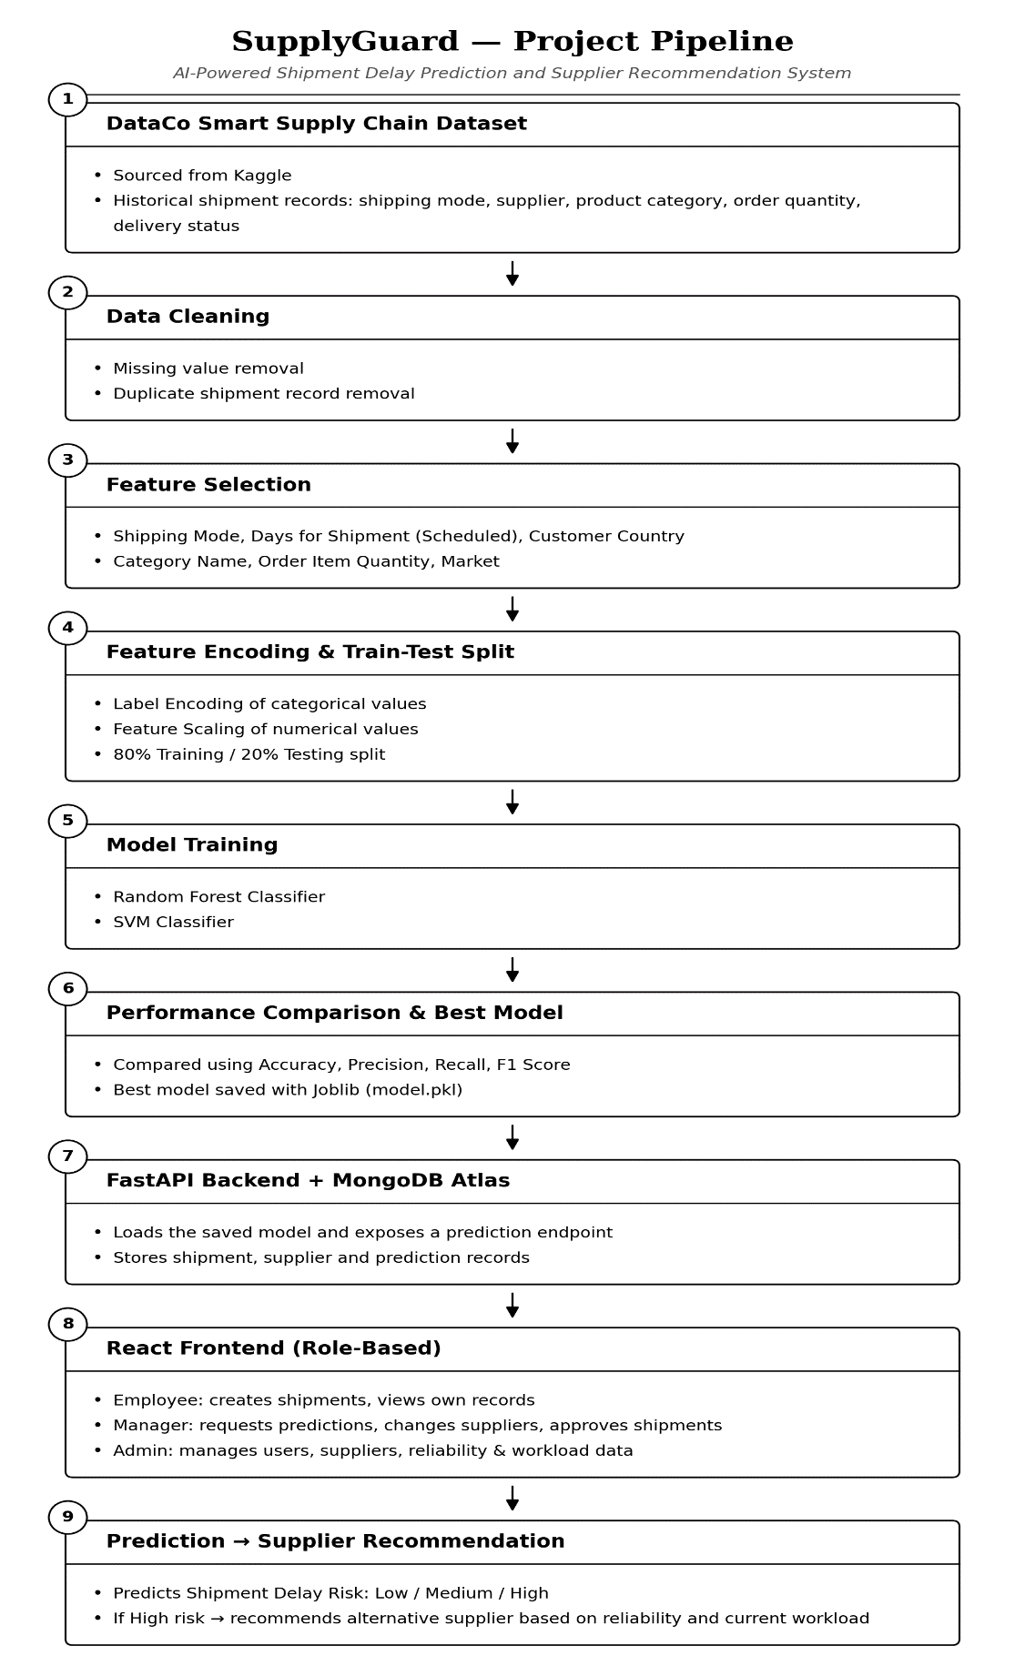
Fig. 3.14 Project Pipeline of the Proposed SupplyGuard System

Level 1: Dataset Collection
The project begins with the DataCo Smart Supply Chain Dataset, which contains historical records related to customers, products, orders, shipments, markets, and geographical information. The dataset is used to develop and evaluate the proposed Machine Learning models for shipment late-delivery-risk prediction.
Level 2: Data Preprocessing
The dataset is analyzed to understand its structure, attributes, data types, missing values, duplicate records, and statistical characteristics. Relevant features are selected, unsuitable attributes are excluded, and categorical variables are converted into numerical form using One-Hot Encoding to prepare the data for model training.
Level 3: Feature Selection and Engineering
Relevant features for shipment late-delivery-risk prediction are selected from the dataset. Temporal features are derived from the order date (DateOrders) attribute, and an interaction feature is created by combining Shipping Mode and Order Hour. The final feature set is transformed into a suitable format for Machine Learning.Level
4: Model Training
The processed data is used to train the proposed Random Forest and Support Vector Machine (SVM) classification models. Random Forest is trained using the training dataset and uses 500 decision trees, while the SVM experiment uses a stratified subset of 30,000 training records due to its higher computational cost.
Level 5: Model Evaluation
The trained models are evaluated using Accuracy, Precision, Recall, F1-Score, and ROC-AUC. The performance results are compared under the experimental configurations used in the project, and Random Forest is selected as the final prediction model.
Level 6: Supply Chain Risk Prediction
New shipment information is provided through the web interface and processed using the saved Machine Learning pipeline. The final Random Forest model generates a late-delivery probability, which is compared with a threshold of 0.41 to determine whether the shipment is classified as having late-delivery risk or no late-delivery risk.
Level 8: Result Display
The prediction result is displayed through the SupplyGuard webpage. The user can view the predicted late-delivery probability and the corresponding risk classification. The process can then be repeated for another shipment record.
3.6 Feasibility Analysis
Feasibility analysis evaluates whether a proposed system can be successfully developed and implemented using the available resources, technologies, budget, and operating environment. For the proposed SupplyGuard system, the feasibility study considers technical, economic, and operational aspects to determine whether the system can effectively predict shipment late-delivery risk while remaining practical and user-friendly.
3.6.1 Technical Feasibility
Technical feasibility evaluates whether the required technologies, hardware, software, and development tools are available to implement the proposed system. SupplyGuard is developed using Python and Machine Learning libraries such as Pandas, NumPy, Scikit-learn, Matplotlib, and Joblib. The system uses Random Forest and Support Vector Machine (SVM) for shipment late-delivery-risk prediction and provides a web-based interface for entering shipment information and displaying prediction results.
These technologies are widely available and support data preprocessing, feature engineering, One-Hot Encoding, model training, evaluation, model saving, and prediction. The system can be developed and executed using standard computer hardware without specialized infrastructure. Therefore, the proposed SupplyGuard system is technically feasible.
3.6.2 Economic Feasibility
Economic feasibility assesses whether the proposed system can be developed and implemented within a reasonable budget. SupplyGuard primarily uses open-source programming languages, Machine Learning libraries, and freely available development tools, reducing the need for software licensing costs
The system can be developed using standard computer hardware without requiring specialized infrastructure. The DataCo Smart Supply Chain Dataset is available for use in the project, further reducing data acquisition costs. Therefore, the overall development cost is relatively low, making the proposed SupplyGuard system economically feasible
3.6.3 Operational Feasibility
Operational feasibility determines whether the proposed system can function effectively within its intended environment and satisfy its basic user requirements. SupplyGuard provides a simple web-based interface through which users can enter the required shipment information and obtain a late-delivery-risk prediction.
The system processes the entered information using the saved Machine Learning pipeline and Random Forest model and displays the late-delivery probability and corresponding risk classification. The interface requires only the relevant shipment information as input and presents the prediction result in a simple format. Therefore, the proposed SupplyGuard system is operationally feasible.

3.8 SYSTEMENVIRONMENT
The system environment specifies the software tools, Machine Learning libraries, and hardware resources required for the development and implementation of the proposed SupplyGuard: AI-Powered Shipment Delay Prediction System. The project uses standard software tools and computing resources for supply chain data analysis, feature engineering, data preprocessing, Machine Learning model development, evaluation, and web-based prediction.

3.8.1 Software Environment
The software environment consists of Python and commonly used open-source libraries for data analysis, preprocessing, Machine Learning, visualization, and model deployment. Visual Studio Code is used for project implementation and development. Python libraries such as Pandas and NumPy support dataset handling and numerical operations, while Scikit-learn provides the preprocessing, Random Forest, SVM, and evaluation components. Matplotlib is used for data visualization, and Joblib is used to save and load the trained Machine Learning pipeline.

Software / Tool | Purpose
Python | Programming language used for Machine Learning implementation
Visual Studio Code | Code development and project implementation
Pandas | Dataset handling and data analysis
NumPy | Numerical and array-based computations
Scikit-learn | One-Hot Encoding, Random Forest, SVM, data splitting, and model evaluation
Matplotlib | Data visualization and model-result visualization
Joblib | Saving and loading the trained Machine Learning pipeline
Web Interface | Accepting shipment information and displaying prediction results

3.8.2 Hardware Environment
The proposed SupplyGuard system does not require specialized hardware for its development or operation. A standard laptop or desktop computer with sufficient processing capability, memory, and storage can be used for supply chain data analysis, feature engineering, Machine Learning model training, testing, and web interface development.
Hardware Component | Minimum Requirement
Processor | Intel Core i5 or equivalent processor
RAM | 8 GB or higher
Storage | 256 GB or higher
Display | Standard laptop or desktop display
Internet Connection | Stable internet connection for required web resources

4. SYSTEMDESIGN
4.1 MODEL(S) BUILDING
Model building is the central phase of the proposed SupplyGuard shipment late-delivery-risk prediction system. In this phase, the processed DataCo Smart Supply Chain Dataset is used to develop Machine Learning models for classifying shipments into late-delivery-risk and no-late-delivery-risk classes. Random Forest and Support Vector Machine (SVM) are implemented and evaluated to compare their prediction performance.
The model-building process consists of implementation, model planning, training, and testing. The dataset is divided into training and testing sets, the models are trained using the prepared features, and their performance is evaluated using Accuracy, Precision, Recall, F1-Score, ROC-AUC, and Confusion Matrix.
4.1.1 Implementation Code
The Machine Learning component of the SupplyGuard: AI-Powered Shipment Delay Prediction System is implemented in Python using the Scikit-learn library for feature transformation, model training, and evaluation. The system uses Random Forest as the final prediction algorithm and Support Vector Machine (SVM) as the comparison algorithm. The selected shipment features are processed using a Scikit-learn preprocessing pipeline, where categorical variables are converted into numerical representations using One-Hot Encoding, while numerical features are passed directly to the Machine Learning models. The important parts of the implementation are shown below.
preprocessor = ColumnTransformer(
transformers=[
("cat", OneHotEncoder(handle_unknown="ignore"),
categorical_features),
("num", "passthrough",
numerical_features)
]
)
The ColumnTransformer applies different preprocessing operations according to the type of feature. The categorical features are transformed using One-Hot Encoding, with handle_unknown="ignore" allowing the pipeline to process previously unseen categorical values during prediction. The numerical features are passed through without scaling because the final Random Forest model does not require feature standardization.
The final model uses 31 selected features, consisting of 13 categorical features and 18 numerical features. After One-Hot Encoding, these features are transformed into a higher-dimensional numerical feature matrix containing 2,075 transformed features.
The preprocessing component is combined with the Random Forest classifier in a Scikit-learn Pipeline so that the same feature transformation is automatically applied during training, testing, and prediction.
rf_pipeline = Pipeline([
("preprocessor", preprocessor),
("classifier", RandomForestClassifier(
n_estimators=500,
min_samples_leaf=2,
random_state=42,
n_jobs=-1
))
])
The above implementation creates the final Random Forest model. The classifier consists of 500 decision trees, with min_samples_leaf=2 used to control the minimum number of samples required at a leaf node. random_state=42 ensures reproducibility, while n_jobs=-1 allows the available processor cores to be used during training.
The SVM model is implemented as a comparison model using an RBF kernel.
svm_model = SVC(
kernel="rbf",
C=1.0,
gamma="scale",
probability=True,
random_state=42
)
The SVM uses an RBF (Radial Basis Function) kernel to model non-linear relationships between the transformed input features. The parameter C=1.0 controls the regularization, while gamma="scale" determines the kernel coefficient automatically from the input data. Probability estimation is enabled so that probability-based predictions can be obtained.
Because SVM requires considerably more computational time when applied to the complete training dataset, the SVM experiment is trained using a stratified subset of 30,000 records from the training data. The Random Forest model, in contrast, is trained using the complete training dataset of 144,415 records.
Table 4.1: Model Hyperparameter Configuration
Model | Parameter | Value
Random Forest | n_estimators  min_samples_leaf | 500  2  None  42
  max_depth
  Random_state
SVM | Kernel  C  gamma  random_state | 300  1.0  scale  42
Table 4.1: Model Hyperparameter Configuration
The Machine Learning pipeline ensures that preprocessing is learned from the training data and then consistently applied to the testing data and new shipment records. This prevents differences between the data preparation used during model training and the data preparation used during prediction.
For prediction, the saved SupplyGuard pipeline receives the shipment information entered through the web interface. The input is converted into the same feature structure used during model training, and the trained Random Forest model generates a probability of late delivery.
prediction_probability = model.predict_proba(input_data)[0][1]
if prediction_probability >= 0.41:
prediction = 1
else:
prediction = 0
The predict_proba() function generates the probability associated with the late-delivery-risk class. In SupplyGuard, a threshold of 0.41 is used to convert the probability into the final binary prediction. A probability of 0.41 or higher is classified as Late-Delivery Risk, while a probability below 0.41 is classified as No Late-Delivery Risk.
The trained model, preprocessing components, selected feature information, threshold, and evaluation results are saved for later use by the web interface. Therefore, when a user enters new shipment information, the saved Machine Learning pipeline performs the required preprocessing automatically and generates the late-delivery probability and corresponding risk classification.
4.1.2 Model Planning (Training/Testing Split of the Dataset)
Model planning involves dividing the prepared dataset into separate subsets so that the performance of the Machine Learning models can be measured on shipment records that were not used during training. The DataCo Smart Supply Chain Dataset contains 180,519 records, with Late_delivery_risk as the target variable. The target contains two classes: 0 (No Late-Delivery Risk) and 1 (Late-Delivery Risk). The dataset is divided into 80% training data and 20% testing data using stratified splitting.
Dataset | Number of Records | Percentage
Training Data | 144,415 | 80%
Testing Data | 36,104 | 20%
Total | 180,519 | 100%
The following code is used to divide the dataset into training and testing sets.
X = df[final_features]
y = df["Late_delivery_risk"]
X_train, X_test, y_train, y_test = train_test_split(
X,
y,
test_size=0.2,
random_state=42,
stratify=y
)
The train_test_split() function divides the dataset into training and testing subsets. The test_size=0.2 parameter reserves 20% of the records for testing, while random_state=42 makes the split reproducible. The stratify=y parameter maintains the proportion of the two late-delivery-risk classes in both subsets.
The complete dataset contains 81,542 records (45.17%) belonging to class 0 and 98,977 records (54.83%) belonging to class 1. Stratified splitting preserves this class distribution approximately in both the training and testing datasets.
The training dataset containing 144,415 records is used to develop the Random Forest model and conduct the SVM experiment. The testing dataset containing 36,104 records is kept separate from model training and is used to evaluate the performance of both algorithms on unseen shipment records. The Random Forest is trained using the complete training dataset, while the SVM experiment uses a stratified subset of 30,000 records from the training data because of its higher computational cost.
4.1.3 Training – Build the Model Using the Train Dataset
The training phase builds the proposed Machine Learning classifiers using the training dataset. The input features are stored in X_train, while the corresponding target values of Late_delivery_risk are stored in y_train. The Random Forest model is trained using all 144,415 training records, while the SVM experiment is trained using a stratified subset of 30,000 records from the training data because of its higher computational cost.
The Random Forest model is trained through the complete preprocessing pipeline, which applies One-Hot Encoding to the categorical features before passing the transformed data to the classifier
rf_pipeline.fit(X_train, y_train)
The final Random Forest model consists of 500 decision trees. Each tree is constructed using randomly selected samples and features from the training data, and the predictions from the individual trees are combined to produce the classification result. The model uses min_samples_leaf=2, random_state=42, and n_jobs=-1.
The SVM model is trained separately using a stratified subset of 30,000 records from the training dataset
svm_model.fit(X_train_svm, y_train_svm)
The SVM uses an RBF kernel to identify a non-linear decision boundary between the two target classes. The model uses C=1.0, gamma="scale", and probability estimation enabled.
The preprocessing pipeline is fitted using the training data so that the One-Hot Encoding categories are learned from the training records. The same fitted preprocessing is then applied to the test data and new shipment records. This ensures consistency between the data used for model training and the data used for prediction.
The fit() method learns the relationship between the selected shipment features and the target variable, Late_delivery_risk. After training, the models are ready to generate predictions for the held-out test dataset.
4.1.4 Testing – Evaluate the Performance of the Model Using the Test Dataset
After training, both Machine Learning models are evaluated using the 36,104 test records, which were not used during model training. The predictions generated by the models are compared with the actual Late_delivery_risk values stored in y_test.
The following code is used to generate predictions from the Random Forest model:
rf_preds = rf_pipeline.predict(X_test)
rf_proba = rf_pipeline.predict_proba(X_test)[:, 1]
The SVM model is evaluated using the same held-out test dataset:
svm_preds = svm_model.predict(X_test_transformed)
svm_proba = svm_model.predict_proba(X_test_transformed)[:, 1]

5. RESULTS AND DISCUSSION
5.1 COMPARISON OF MODELS
The performance of the Random Forest and Support Vector Machine (SVM) models was compared using the same held-out test dataset of 36,104 shipment records. The models were evaluated using Accuracy, Precision, Recall, F1-Score, and ROC-AUC to measure their ability to classify shipments according to Late_delivery_risk. Table 5.1 presents the performance comparison of the two models.
Evaluation Metric | Random Forest | SVM
Accuracy | 86.40% | 72.42%
Precision | 86.18% | 78.47%
Recall | 89.56% | 68.50%
F1-Score | 87.84% | 73.15%
ROC-AUC | 93.13% | 79.21%
Table 5.1: Performance Comparison of Random Forest and SVM on the Test Set
The Random Forest model obtained an Accuracy of 86.40% and an F1-Score of 87.84%, while the SVM model obtained an Accuracy of 72.42% and an F1-Score of 73.15%. Random Forest also achieved higher Precision, Recall, and ROC-AUC values in the experimental comparison.
The difference in Accuracy between the two models is 13.98 percentage points, while the difference in F1-Score is 14.69 percentage points. Random Forest achieved a Recall of 89.56%, indicating that it correctly identifies a high proportion of shipments belonging to the late-delivery-risk class. Its ROC-AUC of 93.13% also indicates strong discrimination between the two target classes on the test data.
However, the comparison should be interpreted according to the experimental configurations used in the project. Random Forest was trained using the complete 144,415-record training dataset, whereas SVM was trained using a stratified subset of 30,000 training records because of its higher computational cost. Therefore, the measured difference reflects both the model algorithms and their respective training configurations.
Based on the experimental results, Random Forest is used as the final prediction model in SupplyGuard. The graphical comparison of the model performance is shown in Figure 5.1.
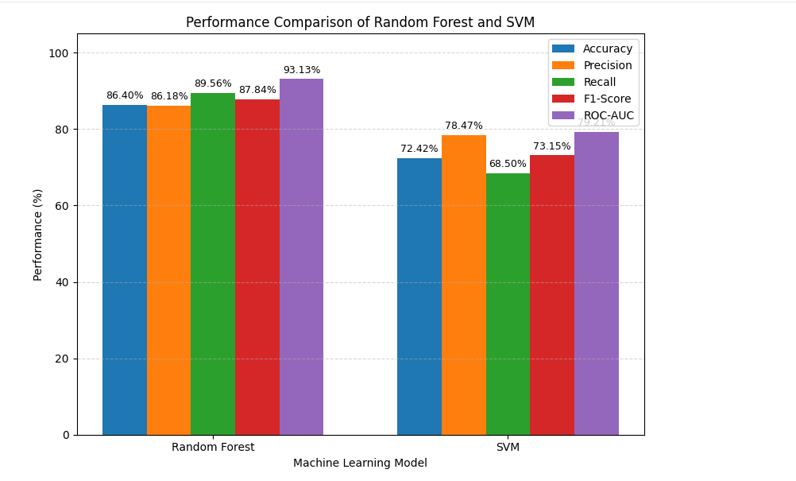
Figure 5.1: Graphical Comparison of Random Forest and SVM

5.2 EVALUATION METRICS
Evaluation metrics are used to measure how effectively the Machine Learning models predict the late-delivery-risk class of a shipment. In SupplyGuard, the target variable Late_delivery_risk contains two classes: 0 (No Late-Delivery Risk) and 1 (Late-Delivery Risk).
For the late-delivery-risk class, True Positives (TP) are shipments correctly predicted as having late-delivery risk, False Positives (FP) are shipments predicted as having late-delivery risk when they actually do not, False Negatives (FN) are shipments having late-delivery risk that are incorrectly predicted as no risk, and True Negatives (TN) are shipments correctly predicted as having no late-delivery risk.
1. Accuracy
Accuracy represents the proportion of all shipment records that are correctly classified by the model.
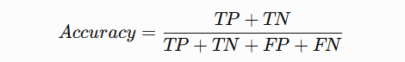
Accuracy provides an overall measure of the correctness of the model's predictions.
2. Precision
Precision measures how many of the shipments predicted as having late-delivery risk actually belong to the late-delivery-risk class.
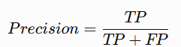
A higher Precision indicates that fewer shipments are incorrectly classified as having late-delivery risk.
3. Recall
Recall measures how many of the shipments that actually have late-delivery risk are correctly identified by the model.
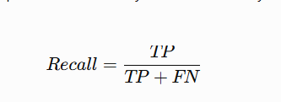
Recall is particularly important for identifying shipments that are actually at risk of late delivery, since a False Negative represents a risky shipment that was not identified.
4. F1-Score
F1-Score is the harmonic mean of Precision and Recall. It provides a combined measure of the model's ability to correctly identify the late-delivery-risk class while limiting false positive predictions.
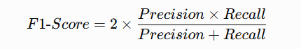
A higher F1-Score indicates a better balance between Precision and Recall.
5.ROC-AUC
ROC-AUC (Receiver Operating Characteristic – Area Under the Curve) measures the model's ability to distinguish between shipments with late-delivery risk and shipments without late-delivery risk across different classification thresholds. A higher ROC-AUC value indicates better discrimination between the two classes.
The ROC-AUC metric is calculated from the predicted probability scores generated by the Machine Learning model rather than only from the final binary predictions.
These evaluation metrics are used in SupplyGuard to compare the performance of the Random Forest and SVM models. The obtained results are presented in the following sections.

5.3 CONFUSION MATRIX
A confusion matrix compares the actual class of each test shipment with the class predicted by the Machine Learning model. In the SupplyGuard confusion matrix, the rows represent the actual classes, while the columns represent the predicted classes. The diagonal elements represent correctly classified shipments, whereas the off-diagonal elements represent incorrect predictions.
For SupplyGuard, the two classes are 0 (No Late-Delivery Risk) and 1 (Late-Delivery Risk). The confusion matrix of the final Random Forest model was generated using the 36,104 records in the test dataset.
5.3.1 Random Forest Confusion Matrix
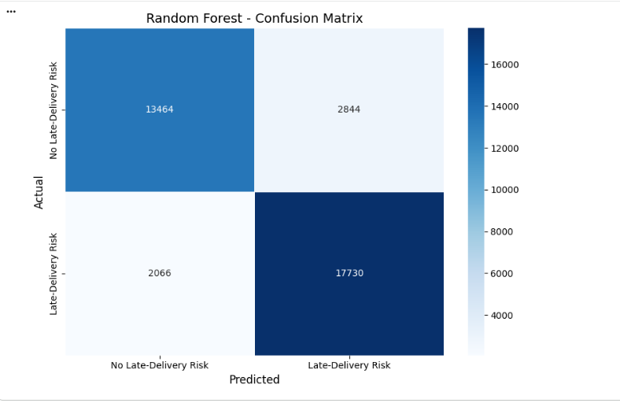
Figure 5.2: Confusion Matrix of Random Forest

Actual \ Predicted | No Late-Delivery Risk (0) | Late-Delivery Risk (1) | Total
No Late-Delivery Risk (0) | 13,464 | 2,844 | 16,308
Late-Delivery Risk (1) | 2,066 | 17,730 | 19,796
Total | 15,530 | 20,574 | 36,104

5.3.2 SVM Confusion Matrix
The SVM confusion matrix was generated using the same 36,104 test shipments used for model evaluation. The rows represent the actual late-delivery-risk classes, while the columns represent the classes predicted by the SVM model. The diagonal values indicate correctly classified shipments, while the off-diagonal values represent misclassified shipments.
Table 5.3: Confusion Matrix Values of SVM
The confusion matrix shows the True Positive, True Negative, False Positive, and False Negative predictions produced by the SVM model. These values provide the basis for calculating Accuracy, Precision, Recall, and F1-Score. The SVM achieved an Accuracy of 72.42%, Precision of 78.47%, Recall of 68.50%, and F1-Score of 73.15% on the test dataset.
The SVM confusion matrix provides a direct view of the correctly and incorrectly classified shipments and supports comparison with the Random Forest confusion matrix.
5.4 RELEVANT METRICS CALCULATED FROM CONFUSION MATRIX
Precision, Recall, and F1-Score for each class are calculated from the confusion matrix of the final Random Forest model. For the No Late-Delivery Risk class, the True Positive (TP) value is 13,464, the False Positive (FP) value is 2,066, and the False Negative (FN) value is 2,844. Therefore:
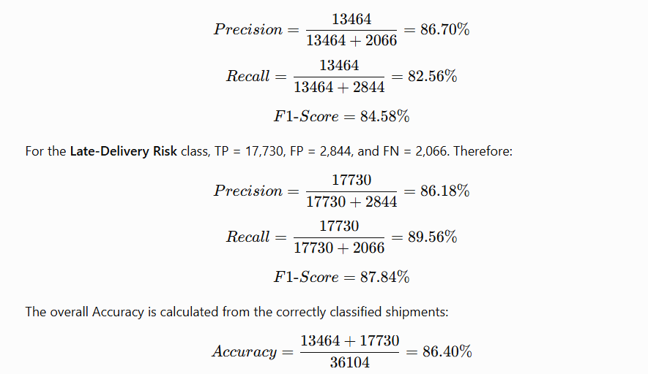
The calculated values are summarized in Table 5.4.
Table 5.4: Per-Class Metrics Calculated from the Confusion Matrix
Model | Class | Precision | Recall | F1-Score | Support
Random Forest | No Late-Delivery Risk | 86.70% | 82.56% | 84.58% | 16,308
Random Forest | Late-Delivery Risk | 86.18% | 89.56% | 87.84% | 19,796
Random Forest | Macro Average | 86.44% | 86.06% | 86.21% | 36,104
5.4.1 MISCLASSIFICATION ANALYSIS
The confusion matrix also provides information about the types of errors made by the Random Forest model. The following table summarizes the misclassified shipments.
Table 5.5: Misclassifications by Type
Actual Class | Predicted Class | Number of Shipments | Percentage of Actual Class
No Late-Delivery Risk | Late-Delivery Risk | 2,844 | 17.44%
Late-Delivery Risk | No Late-Delivery Risk | 2,066 | 10.44%
Total Errors | — | 4,910 | 13.60% of test set

The Random Forest model incorrectly classified 2,844 shipments that actually had no late-delivery risk as having late-delivery risk. These are False Positive predictions. In comparison, 2,066 shipments that actually had late-delivery risk were predicted as having no late-delivery risk, representing False Negative predictions.
The number of False Negatives is particularly relevant because these represent shipments with actual late-delivery risk that were not identified by the model. Overall, the model correctly classified 31,194 out of 36,104 test shipments, while 4,910 shipments were misclassified.

5.5 PREDICTION STATISTICS OF UNSEEN DATA
After comparing the two models, Random Forest was selected as the final prediction model. The 20% test split containing 36,104 shipment records was not used during model training and was therefore used as the unseen test data for evaluating the final model. Table 5.5 presents the prediction statistics of Random Forest on these unseen shipment records.

Class | Actual Shipments | Predicted Shipments | Correctly Classified | Class Accuracy (Recall)
No Late-Delivery Risk | 16,308 | 15,530 | 13,464 | 82.56%
Late-Delivery Risk | 19,796 | 20,574 | 17,730 | 89.56%
Total | 36,104 | 36,104 | 31,194 | 86.40%

Table 5.5: Prediction Statistics of the Selected Random Forest Model on Unseen Test Data

Out of the 36,104 unseen test shipments, 31,194 were classified correctly and 4,910 were incorrectly classified.
Correct predictions=13,464+17,730=31,194\text{Correct predictions}=13,464+17,730=31,194 Incorrect predictions=2,844+2,066=4,910\text{Incorrect predictions}=2,844+2,066=4,910
The model correctly identifies 89.56% of the shipments with late-delivery risk, while 82.56% of the shipments without late-delivery risk are correctly identified.

5.6 DISCUSSION OF FINDINGS AND CONCLUSIONS
The experimental results demonstrate that both Random Forest and Support Vector Machine (SVM) were able to classify shipments according to late-delivery risk. Random Forest achieved an Accuracy of 86.40%, while SVM achieved an Accuracy of 72.42% on the test dataset.
The confusion matrix analysis shows that Random Forest correctly classified a large number of shipments in both classes. The model achieved a Recall of 82.56% for No Late-Delivery Risk and 89.56% for Late-Delivery Risk. The SVM model also classified both classes, although its overall performance was lower under the experimental configuration used.
The class-specific analysis of Precision, Recall and F1-Score provides further insight into the classification performance of both models. The prediction on unseen shipment data also demonstrates the use of the trained models for classifying new shipment records.
Overall, the results provide an evaluation of the proposed SupplyGuard shipment late-delivery-risk prediction system using multiple performance measures, confusion matrix analysis, and prediction on unseen data. The findings demonstrate the applicability of Machine Learning for predicting shipment late-delivery risk from historical supply chain data.

